NYS Justice Center for the Protection of People with Special Needs  (Justice Center)  Criminal Background Check Unit  161 Delaware Avenue  Delmar, NY 12054  Fax: 518-549-0464 |  |  |  | Request for Staff Exclusion List  Check Form |  |  |  |  | 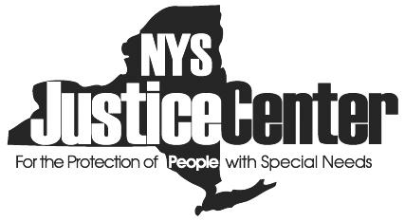
The Justice Center maintains a Vulnerable Persons Central Register (VPCR) that includes a Staff Exclusion List (SEL) containing the names of individuals who have committed serious acts of abuse and are deemed ineligible to work in a position involving regular and substantial contact with a service recipient. Providers must request the Justice Center to conduct a check of the SEL before determining whether to hire or otherwise allow “any person” to have regular and substantial contact with a service recipient. “Any person” can include an employee, administrator, consultant, intern, volunteer, or contractor.

Instructions:
1. The provider’s Authorized Person must complete this form and fax it to the Justice Center’s Criminal
Background Check (CBC) unit for an applicant under serious consideration to be hired or otherwise
permitted to have regular and substantial contact with a service recipient.
2. The Justice Center’s CBC unit will send the Authorized Person an email indicating the results of the
SEL check.
3. If the Applicant is on the SEL, he or she may not be hired in a position involving regular and
substantial contact with a service recipient in a facility or provider agency defined in
Social Services Law §488(4) or by other providers of services in programs licensed or certified by
the Office of Mental Health, Office for People With Developmental Disabilities, Office of Alcohol and
Substance Abuse Services, Office of Children and Family Services, Department of Health and State
Education Department.
4. If the Applicant is on the SEL, certain other providers have discretion whether to hire the individual
as provided in Social Services Law §495(3).
5. If the Applicant is not on the SEL, a criminal background check through the Justice Center, if
required, and an inquiry of the Statewide Central Register of Child Abuse and Maltreatment through
the Office of Children and Family Services, if required, must be conducted.

Part 1. Applicant Information (Please Print)
Last Name: |  |  |  |  |  | First Name: |  |  |  |  |  | MI:
Date of Birth: |  |  |  |  | Social Security Number: |  |  |  |  | Alien Reg#:
Applicant address: |  |  |  |  |  | Applicant type:
Facility/Provider Name:
Address:
State Oversight Agency: OMH OPWDD OCFS DOH SED OASAS |  |  |  |  |  |  |  |  |  |  | Please circle appropriate agency(ies)
Part 2. Authorized Person Information Please print clearly
Name:  (Please Print) |  |  |  |  |  |  |  | Email:
Signature: |  |  |  |  |  |  |  | Phone:
Facility/Provider name: |  |  |  |  |  |  |  | Address:
JC CBC Form 3 Dated: 6/13

