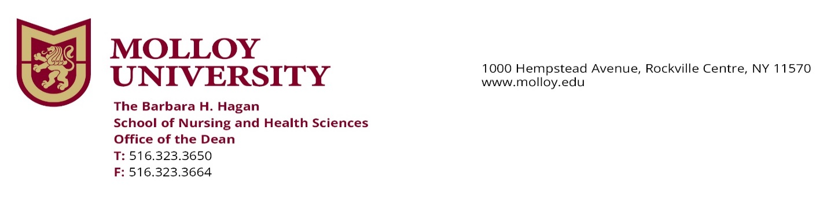

July 31, 2023

Dear Student,

In advance, welcome to the fall semester. We know that you are excited to begin a new academic year this September. The nursing faculty are looking forward to seeing you soon.

Clinical learning is an essential component of your program. We have agreements for clinical placements with many health systems in the region. Clinical sites have many health clearance and other requirements for student placement for clinical experiences. These requirements may *differ from, and are in addition to*, the general health requirements that Molloy University specifies for students in all majors, and we must comply with these.

In just the past few days, we have been advised by many of our clinical affiliates that COVID vaccination will not be required for clinical placements, but both the Department of Health and clinical sites *strongly recommend* that all nurses and nursing students be vaccinated for COVID.   Our clinical affiliates must report the vaccine status of students and other clinicians to the NY state Department of Health. Therefore, students must continue to upload documentation of COVID vaccination status into their CastleBranch accounts.  However, vaccination is not required to be cleared for clinical experiences for fall 2023.

It is important to note that there continue to be some hospital placements requiring COVID vaccination. If students are placed at these sites, they will be individually notified of this requirement by Dr. Schecter or Dr. Aprigliano, depending on the student’s program and whether they have previously submitted COVID vaccination documentation.   We are obligated to comply with these criteria in order to place students in clinical settings and are unable to exempt students from external clinical clearance requirements.  In addition, we *cannot* change a student’s placement based on vaccine status or vaccine requirement.

Associate Deans, Dr. Schecter (freshmen and transfer students) [rschecter@molloy.edu](mailto:rschecter@molloy.edu) and Dr. Aprigliano (second degree and dual degree students) [taprigliano@molloy.edu](mailto:taprigliano@molloy.edu) , are available to answer any questions that you might have.

Best wishes for a safe and fulfilling end to the summer.

Sincerely,



Marcia Gardner, PhD, RN, CPNP, CPN, ANEF

Dean, The Barbara H. Hagan School of Nursing and Health Sciences