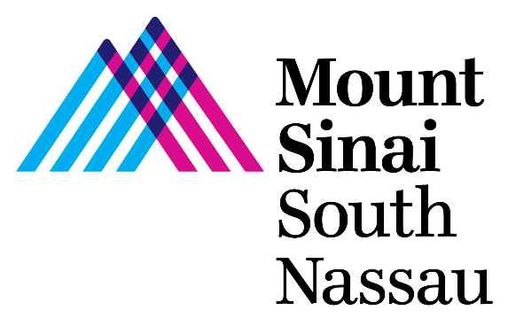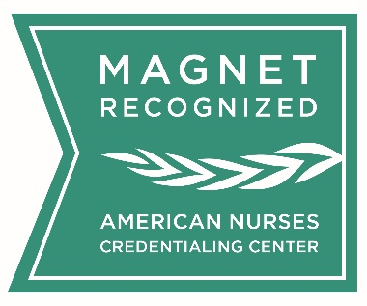

Nursing Student
Guide

Spring 2023

Welcome to Mount Sinai South Nassau!
We are strongly committed to facilitating a positive and safe clinical practicum experience for you on our nursing units. Please read through this guide as it will provide important information related to the logistics and clinical experiences you will be having here at MSSN. Our nursing team is excited to have you at our organization and hope to support a meaningful learning experience for students.
Requirements for clinical placement of students have been established in order to keep our patients, employees, physicians, and students safe within the practice environment.
Number of Student Placements
The number of student placements will be determined by the placement coordinator in collaboration with the unit Nurse Manager.
MSHS will make accommodations for the schools to split student groups into sub-groups but a faculty member must be with each group during clinical.
COVID-19 Vaccination
All students and faculty must be fully vaccinated prior to beginning their MSHS clinical placement. There are no medical or religious exemptions allowed.
Screening
All students and faculty must self-monitor/be screened by the school/faculty to identify those that may be experiencing COVID-19 symptoms prior to the beginning of each practicum day.
Students and faculty that have symptoms cannot attend their clinical assignment and must immediately contact their clinical instructor/hospital for further follow-up.
Personal Protective Equipment
Hospital grade surgical masks must be worn upon entry to the hospital.
PPE, including face masks and eye protection, will be the responsibility of the student/faculty. This PPE must meet MSHS guidelines.
Students/faculty must be provided instructions on the proper donning and doffing of PPE. https://www.cdc.gov/coronavirus/2019-ncov/downloads/A_FS_HCP_COVID19_PPE.pdf

Respirator Mask Fit Testing
Fit testing is the responsibility of the school. (The school will ensure that all students/faculty have current fit testing that will be valid throughout the duration of the clinical placement.)
Pre-Conference and Post-Conference
Student cohorts are permitted to conduct pre-conference or post-conference in the hospital cafeteria. Public Areas such as the Atrium and Lobby waiting areas should not be used for this purpose. Conference Rooms are not available for this purpose.

Orientation to MSSN
Mount Sinai South Nassau provides a general nursing orientation:
- For undergraduate students or graduate student groups, clinical instructors conduct the student orientation and submit documentation to the Nursing Education Department
- For individual graduate nursing students, the orientation packet and materials will be emailed to students for return to Nursing Education

Documents to be completed and submitted by nursing students prior to the start of clinical rotations include the following:
- A completed Self-study Orientation Exam (located at the end of the Mandatory Packet)
- A completed/signed hospital Confidentiality Attestation/ Sexual Harassment Prevention Attestation
- A completed Medical Regulatory Attestation Form from the College ensuring all student health clearance requirements are met. This can be a group attestation on college letterhead from the program coordinator.
- If you require EMR access, a System Access Request Form must be completed, so we can submit to information services.
- All graduate nursing students must submit a copy of their current NYS RN Licensure

Personal Protective Equipment (PPE) is Required while On-Site at any of the Mount Sinai Health System Hospitals
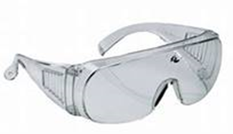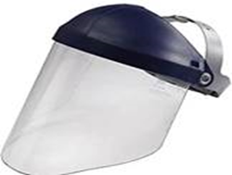
In addition to Standard Precautions
A surgical mask is required at all times while on hospital premises.
N95 respirators and eye protection are required while providing direct patient care to positive or suspected COVID patients.

Reusable eye protection is made of hard plastic. These items can be reused for a longer period of time but must be discarded when worn or damaged. They can be cleaned with soap and water, hydrogen peroxide wipes, or alcohol prep pads between uses. After cleaning, they can be dried with paper towels or allowed to air dry.
PARKING GUIDELINES
The availability of parking at the hospital remains a primary concern of employees, students, physicians, patients, visitors and our neighboring community. Mount Sinai South Nassau (MSSN) requests that all students with weekday clinical placements park, in Rockville Centre Municipal Lot #12, just west of Long Beach Road along the north side of Sunrise Highway, adjacent to the LIRR tracks. Students are not permitted to park in any of the main hospital lots.

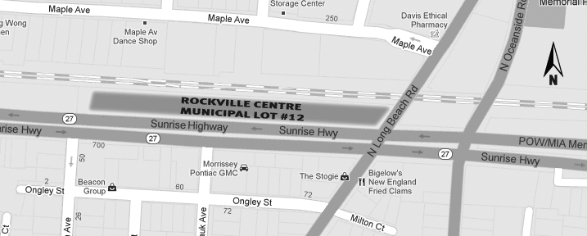

Hours Monday-Friday 6am-9pm:
Peak Hours 6am-10am, & 2pm-6pm]
For service during Off Peak Hours 10am-2pm & after 6pm please contact the Shuttle/Valet at 526-632-3098. (If unavailable contact the operator for assistance at 516-632-3200)

These spaces are reserved for MSSN employees and students who work Monday- Friday, during shifts spanning the beginning and ending hours of 6am-8pm. A free shuttle service will transport employees and students between Lot #12 and the hospital’s front entrance throughout the day. The lot is 7/10ths of a mile from the hospital’s front door and travel time from Lot #12 to the hospital is less than 10 minutes. It’s recommended to allocate ample time for shuttle transport and factor this into your commuting plan.

- There are no meters in this lot and a sticker is not required. We ask only that you park courteously in the MSSN Designated Lot.

- The shuttle is operated by Sodexo, the company that has provided management services for our hospital’s Food & Nutrition department.

- During off-peak hours (between 12am-2p, & after 6pm) bus service is by request only- contact the Shuttle/Valet directly at 516-632-3098. Vehicle security will also be assured by the RVC Police Department who regularly patrol all municipal lots. Your vehicle is as safe as if it were parked anywhere else.

Please be aware that there are restrictions on Parking in the residential area surrounding Mount Sinai South Nassau enforced by the Town of Hempstead. Residential parking permits are required for roadways surrounding Mount Sinai South Nassau campus extending from Sunrise Highway south to Foxhurst Rd. and from Long Beach Rd. to Yorktown Rd. (east), specifically on Allen Avenue, Arthur Court, Bedell Avenue, Columbus Avenue, Eileen Road, George Street, Harvey Avenue, Howard Place, Johnson Place, Mount Avenue, Nassau Parkway, Rockville Centre Parkway, Seiffert Court, Southard Avenue and Washington Avenue.

Dress Code
- Instructors will be provided with a photo ID issued by MSSN.
- Students must wear the uniform and identification designated by their nursing program which must be displayed at all times while on MSSN premises.
In certain settings students may be required to wear scrub attire (OR, DR, or other perioperative or procedural areas). This will be provided by the hospital but must be returned at the end of the day.
Valuables
As secure storage space is unavailable at MSSN, students and faculty are encouraged to come to the hospital only with what can be carried on their person.
Meals
Students and faculty may use the MSSN cafeteria or coffee shop services. Please maintain physical distancing and do not move or combine tables and chairs.
Medication Administration
- Nursing students may administer medication ONLY under the direct supervision of the clinical instructor or preceptor. Clinical Instructors who have been trained in the use of the Sunrise/Allscripts Application, will be responsible for medication administration for patients assigned to student nurses.
- Medications must be documented on the E-MAR at the time they are administered.
- The clinical instructor/student must inform the primary nurse prior to administering any medications to a patient.
- Nursing students are not permitted to perform fingersticks on patients using the glucometer.

Clinical expectations for students are as follows:
- Be present (listen to bedside shift report, attend unit briefs, attend interdisciplinary plan of care rounds)
- View the patient care plan prior to giving care to the patients and discuss any questions with the primary nurse.
- Students can be a positive part of the patient experience at MSSN:
- Learn your patient’s story
- Facilitate use of our patient education TV (pCARE) with your patient & discuss what they have learned
- As appropriate, promote patient mobility (ambulate with your patient)
- Direct technical questions to the instructor first, seeking out the patient's primary nurse for any further clarification.
- When you leave the patient care unit for a break, inform the primary nurse. Your instructor and the patient's nurse should be apprised of the status of the patient prior to all break.
- Communicate with the instructor and the nurse assigned to the patient. You must report all pertinent information including changes in the patient’s condition. At the end of your shift, you should provide a comprehensive report on your patient’s or patients’ condition to the nurse responsible for each of your patient.
- Direct any problems you are having related to staff, patients, physicians, etc., to your instructor (or preceptor) who will determine whether or not to involve the person directly or discuss the issue with the Nurse Manager.
- If a nursing student nurse is involved in an occurrence, the instructor (or preceptor) and the Nurse Manager will investigate the incident and utilize this opportunity as a learning experience. The Director of Nursing Education or Student Placement Coordinator will be informed to ensure appropriate follow-up.

