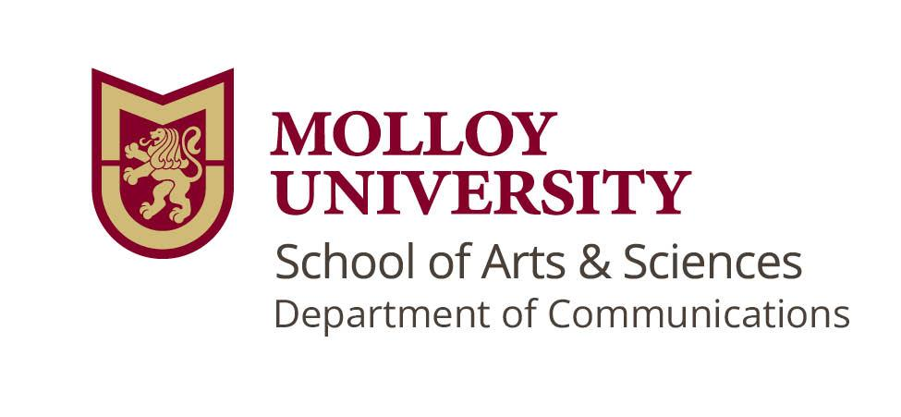
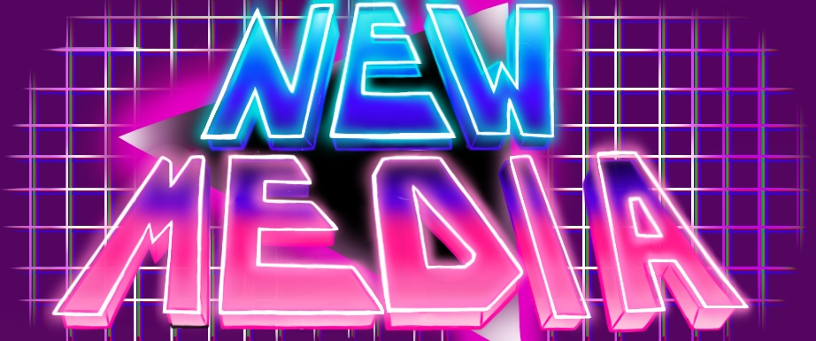

Communications: New Media B.S.
In the New Media program, you'll get hands-on with social-first photography, multimedia production, social media management, digital design, web design, and the Adobe Creative Suite. Alongside practical skills, we teach essential theories and concepts that make our students critical thinkers and conscientious digital media producers. Our flexible program gives students the power to customize their education for a variety of exciting careers in this field. The New Media B.S. is the perfect way to dive into the world of digital creativity!
Essential Skills:
Essential skills refer to the knowledge gained from a liberal arts education. They provide a framework to guide students’ progress toward their degree, but also prepare students for a broad range of career paths. A recent survey from the Association of American Colleges and Universities (AAC&U) shows employers “strongly agree” that “regardless of a student’s field of study” liberal arts skills best prepare students to enter the job market in their career of choice.
- Information Literacy:
  - Gather and analyze information from a diverse set of sources and individuals to fully understand a problem.
  - Manipulate information, construct ideas, and use technology to achieve specific goals.
- Technology
  - Quickly adapt to new or unfamiliar technologies.
  - Identify appropriate technology for completing specific tasks.
  - Use technology to improve efficiency and productivity of their work.
  - Use technology to achieve course related goals.
  - Navigate change and be open to learning new technologies.
- Personal and Social Responsibility:
  - Civic knowledge and engagement—local and global
  - Ethical reasoning and action
  - Foundations and skills for lifelong learning
- Integrative and Applied Learning
  - application of knowledge, skills, and responsibilities to new settings and complex problems.
  - Synthesis and advanced accomplishment across general and specialized studies.

FIRST YEAR
Fall Courses |  | Spring Courses
COM 1150: Digital Literacies | 3 | COM 2280: Writing for the Web | 3
COM 2260: New Media | 3 | Philosophy (Gen Ed) | 3
ENG 1100 | 3 | Modern Language (Gen. Ed.) | 3
ART or MUS (Gen. Ed.) | 3 | TRS (Gen. Ed.) | 3
HIS / POL / PSY / SOC (Gen. Ed.) | 3 | Elective | 3
FST 1000 | 1
Total Credits | 16 | Total Credits | 15

SECOND YEAR
Fall Courses |  | Spring Courses
COM 2460: Civic Engagement | 3 | COM 2440: Online Content Production | 3
HIS / POL / PSY / SOC (Gen. Ed.) | 3 | COM 3101: Video Storytelling | 3
ETH (Gen. Ed.) | 3 | COM Elective | 3
Modern Language / LIT (Gen. Ed.) | 3 | HIS / POL / PSY / SOC (Gen. Ed.) | 3
Elective | 3 | Elective | 3
Total Credits | 15 | Total Credits | 15

THIRD YEAR
Fall Courses |  | Spring Courses
COM 3920: Advanced Online Content Production | 3 | COM 3090: Technology, Culture, and Power | 3
COM Elective | 3 | COM 3650: Research in Communications | 3
Science (Gen. Ed.) | 3 | Elective | 3
Elective | 3 | CORE (Gen. Ed.) | 4
Elective | 3 | PED (Gen. Ed.) | 1
Total Credits | 15 | Total Credits | 14

FOURTH YEAR
Fall Courses |  | Spring Courses
COM 4600: Internship I | 3 | COM 4900: Communications Capstone | 3
COM Elective | 3 | Elective | 3
MAT (Gen. Ed.) | 3 | Elective | 3
Elective | 3 | Elective | 3
Elective | 3 | Elective | 3
Total Credits | 15 | Total Credits | 15
Total Credits to Graduate |  |  | 120

Honor Society
Lambda Pi Eta (LPH) is the National Communication Association’s official honor society at four-year colleges and universities. LPH has more than 500 active chapters at four-year colleges and universities nationwide.
To be eligible for admission, undergraduate students must meet the following criteria:
- Complete 60 semester credit-hours (90 quarter credit-hours)
- Have a minimum overall cumulative GPA of 3.0
- Complete the equivalent of 12 semester credit-hours (18 quarter credit-hours) in Communication Studies
- Have a minimum GPA of 3.25 for all Communication Studies courses.
- Currently be enrolled as a student in good standing, as determined by the institution's policies.

Related Activities and Associations:
- Anime Club
  - From watching anime episodes, to playing anime video games, to discussing all the latest news within the realm of fandom, the Anime club is open to anyone and everyone that shares a passion for anime, manga, comics, and Japanese culture.
- CREDLY BADGES
  - The Communications department offers all Molloy students the opportunity to earn a CREDLY badge for both Digital Media Production and Advanced Digital Media Production. These badges certify your expertise in specific skills and are a great way to stand out to future employers.
- Media Production Student Club
  - A space for Molloy students to be creative by making movies, podcasts, scripts, and other forms of media. All content is original work outside of Molloy events such as short films, documentaries, and television productions, among other content.
- MolloyLife Student Media
  - A student-run media organization that produces social media content about fellow students and on-campus happenings.
- SPECTRUM Club
  - This club aims to raise awareness and to promote acceptance of the LGBTQIA+ presence on Molloy’s campus. We accept EVERYONE, regardless of gender identity or sexual preference.

Employment Information:
Representative Job Titles Related to this Major Include:
Content Creator, Digital Marketer, Digital Marketing Coordinator, Social Media Marketer, Social Media Strategist, Social Media Coordinator, Marketing Representative, Photographer, Graphic Designer, Designer, User Experience (UX) Designer, Entrepreneur, Podcast Producer, Digital Asset and Archives Associate, Web Writer, Web Developer

Further Resources:
See the following resources: National Association of Colleges & Employers: Career Readiness Defined, AAC&U, What Can I Do with This Major?, Molloy Undergraduate Catalog, and the Molloy New Media YouTube channel featuring student projects

*Notice:
This 8-semester plan is not a contract, either expressed or implied, between the University and the student, but represents a flexible program of the current curriculum which may be altered periodically to carry out the academic objectives of the University. The University specifically reserves the right to change, delete or add to any 8-semester plan at any time within the student’s period of study at the University.

